Spring 2022

AMC Happenings

Professional Software Integrators


Automation &

Management

Consulting, LLC.

Hotel Interface System

Improves Customer Service

The solution to integrate your parking system to your front desk software and key encoding system to allow guests to use the same key for room and parking access. The AMC Hotel Interface System offers options for a full, stand-alone, and event keycard systems to best meet your needs.

Certified Interfaces with Marriott, Galaxy, Opera, and Agilysys Compatible with multiple PARCS
Supports many keycard systems: Saflok, VingCard, TimeLox, Ilco, and Onity using Magstripe and MIFARE RFID room keys

Monthly Parking Interface

Simple System Communications

Interfaces with parking system using a CSV file, API software, or direct database access to accomplish needs.

Setup and update monthlies data and/or setup badges/cards

Lookup the current prepaid balance and/or update the prepaid balance Pull access transactions and generate debits to a third party system, i.e. student account

KEY AMC PROJECTS


Import and update monthlies. Badges/cards will be added or updated in the system

Process queries for new or changed permits and add/update monthlies by card, badge and/or license plate

QR Code Generation program for parking access

Periodically extract access and revenue transactions to feed a dashboard

Signal-Tech Sign Integration to display available count or “FULL” by site or level

Create a reservation that generates a parking pass for an event
Spring 2022 AMC Happenings

Hospital Projects
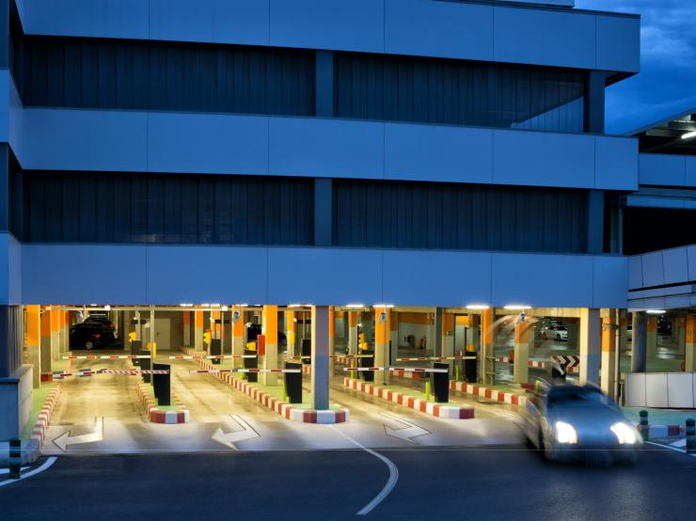

Seamlessly Maintain Access & Flexibility

From a CSV file or API integration, badges/cards will be added to the system. Any badge/card from the system that is not found in the CSV file can be set to inactive to maintain security.

On-demand process creates files for payroll deduction based on duration of stay Automatic Payroll Deductions for parking determined by parking access

University & College Projects
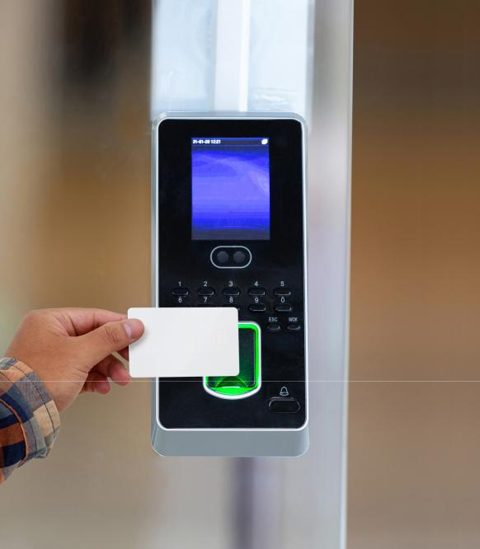

Simplified Parking Solutions

Blackboard | Transact | CBORD CS Gold | C-CURE

Process monthly usage transactions to determine the value

of parking for that day and post a deduction to their prepaid

balance.

5 Day Pass. Set the available parking duration

Set-up monthlies, change parking privileges and update

prepaid balances from student accounts

Process to check extracts from other systems to add/

update monthlies

Interface for University student’s prepaid accounts


We can help you upgrade your aging 3M systems (ScanNet and EFMS) to Windows 10 Pro or 11.


Automation & Management Consulting, LLC

Phone: (406) 442-6665 | Email: bernie@amc-hln.com or ray@amc-hln.com
Website: amc-hln.com | Location: 2804 Billings Avenue, Helena, Montana 59601

Scan For

More Information

